Configuration Guide for EcoDomus PM

1. EcoDomus PM BIM Synchronization

The EcoDomus BIM Connector plug-in will synchronize Revit files with EcoDomus PM to extract design data. Separately, a lightweight 3D file can be generated to render geometry in EcoDomus.
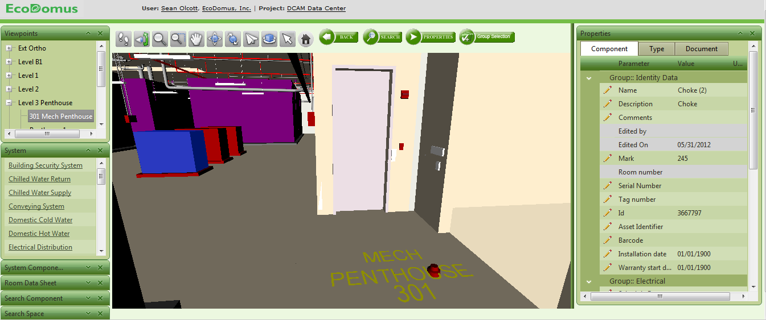
Viewpoints set up for navigation to support data management
Navigate BIM by System

Attributes and Documents associated with BIM object by Type and Component

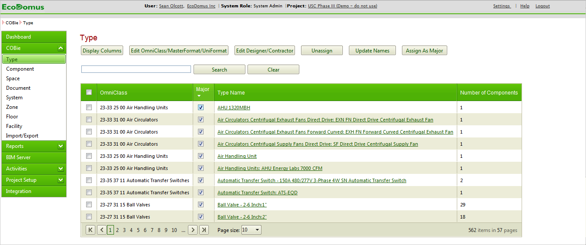

Classification extracted
Correct Naming Convention applied

2. Assigning Project Team Responsibilities to Types
During design, the Project Admin for AE will identify Designers responsible for providing data for Equipment Types in EcoDomus PM.
During construction, the Project Admin for GC will identify “Contractors” responsible for providing data for Equipment Types in EcoDomus PM.
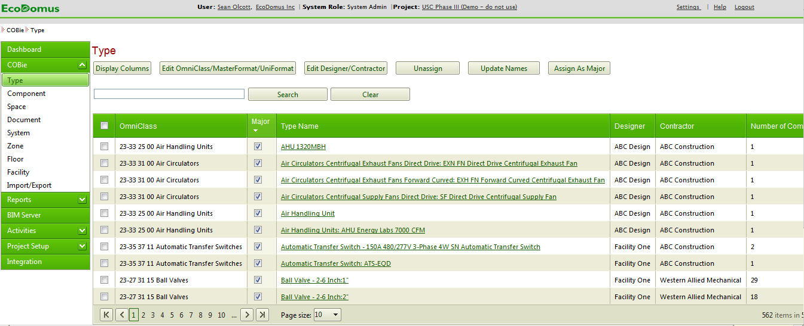
Major Equipment identified
Designers/Contractors assigned

3. Data Input and Editing
GC will input data based on their respective assignments using EcoDomus web forms or the BIM User Interface.

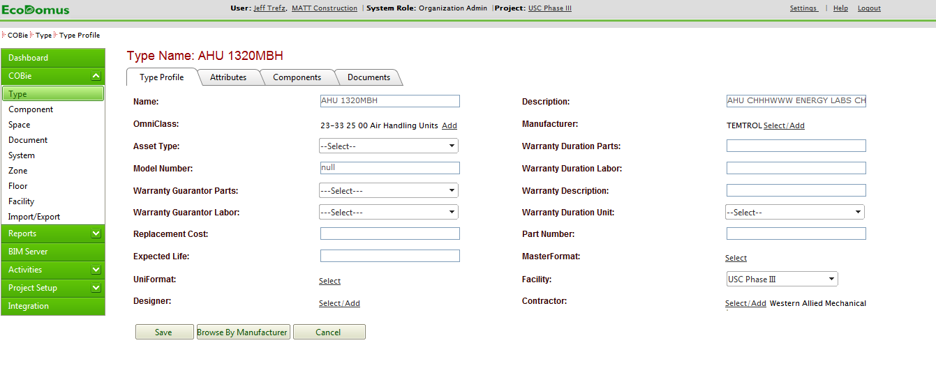
Stakeholders fill in empty fields for default COBie requirements

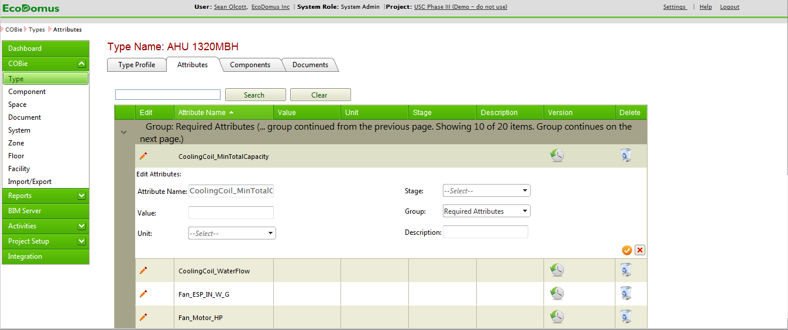
Select Attributes tab to input data for required Extended Attributes

4. COBie Deliverable Export
The BIM Manager will export COBie xls files from EcoDomus at major milestones.

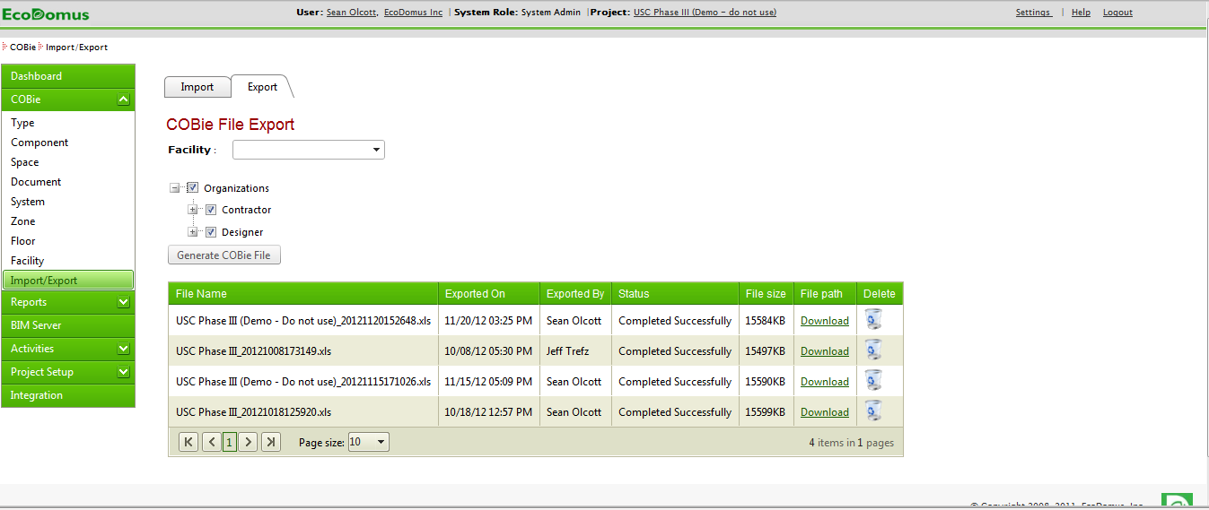
Upload and Download COBie files, for project or split out by Organization (e.g. Designer or Contractor)

