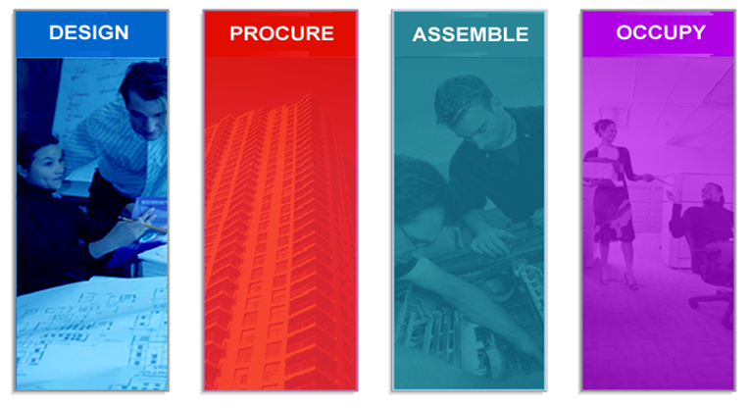
bSa, NBIMS Document #:
Date:
Working Group: BIM-GIS
IDM Use Case: BIM-GIS Information Exchange (BIGie)
Version: 1.0
Contents

Section 1. Workgroup IDM Information 2
Section 2. Use Case Narrative 2
Introduction and Problem Statement 2
Narrative 2
Phase for Use Case 2
Actors 2
Tools 2
Section 3. Tasks/Processes 2
Main Task/Process A 2
Main Task/Process B 2
Main Task/Process C 2
Process Map 2
Post-Conditions/Outcome 2
Comments 2
Glossary 2
References 2
Appendixes 2
BSa Tetrology 2
Appendix B. Omniclass 2

This document has been created by the IDM and MVD Technical Groups in support of NBIMS development and implementation. It is freely distributed to BSa members, industry working groups, and organizations submitting candidate BIM processes for NBIMS consideration.

Authors:
Dianne Davis, CSI, NA IDM Technical Chair
Jan Karlshoj, International IDM Coordinator
Reviewer: Richard See, Technical Chair

This document is based upon the original concept documents authored by Jeff Wix for BuildingSMART.
Additional information provided by: Richard See, Chuck Eastman, GA Tech, Roger Grant, CSI, Louis Hecht.

Section 1. Workgroup IDM Information
IDM Use Case Name: BIM-GIS Spatial Data Information Exchange -BIGie
Please remove the word <Template> and all other text within brackets and template instructions (like this one in blue) from your IDM document. Also, please remove all the blank forms and appendices at the end of this document. All this information is for your benefit, but should NOT appear in your own IDM document. Once the name has been determined include the IDM name and working group name in document footer and front cover page

VERSION HISTORY
No. | Date | Modifications | Author/s

Working Group Members
(participant roles)- Sponsor, Industry Knowledge Expert, WG Leader, Technical Advisor

Name | Organization | Role | Email address
 |  | Working Group Leader

Section 2. Use Case Narrative
IDM Name: BIM-GIS Spatial Data Information Exchange -BIGie
Tetrology Area/s: Operate
Focus Area/s: 36-11 33 00 – Model Documents (model exchanges)

Instructions: A use case describes a particular set of activities that fulfill user requirements for process and information exchanges between two or more end users within a workflow. The use case narrative explains, in plain English, the problem, the proposed process solution, and the benefits. It identifies the stakeholders, actors, and includes a process map (template BPMN) showing workflows, the participants, and the required information exchanges, however, the specific data of an information exchange is identified elsewhere in the Exchange Requirement Template of the IDM activity. When appropriate, it describes how the process/s fit in the overall project or building lifecycle, and the relationship of this IDM to other NBIMS or industry activities.

Introduction and Problem Statement
The introduction describes the requirement, and how by addressing this requirement, this process will either improve an existing industry process or define new processes because of BIM, other technologies and their efficient integration by standardization …

Narrative
Phase for Use Case – 31-40-50-00 Commissioning Phase

Context and Scope
Description of pre-requisites, such as BIM use or processes prior to this IDM ….
- General Uses – categories of this data are
  - Security systems
  - Fire Protection
  - Evacuation Routing
  - Way Finding routes
  - ADA routes
  - Space Analysis
  - Space Management
  - Move management ???
  - Energy Consumption – differentiate from Energy MVD?
  - Facility Energy Performance
    - Energy Sensor location (sub category??
  - MEP equipment location
  - MEP campus system routing
  - Asset location

Related Use Cases and Inter-dependent Processes
…. will be used in xx end user processes, spanning from … to ….

Stakeholders (interested parties impacted by the IDM but not necessarily primary users, ex. Manufacturer of products, vendors, regulators)
Actors (use Omniclass Table 33)
33-21 00 00 Design 33-31 31 00 GIS Engineering 33-55 24 00 Facility Operations
This use case supports the information exchange between ….

Tools
This use case requires …. BIM Model
Prior to the start of this use case, the user will have ….

Non-Functional Requirements These non-functional requirements are required and important for the system and process to operate properly in the environment in which it will be implemented. Ex. Look and Feel Requirements, Performance Requirements, Security Requirements, Usability Requirements

Section 3. Tasks/Processes
The processes are outlined generally in the narrative. Some of the tasks may have sub-processes. The relationship and flow between the tasks is documented in the process map. (The processes may be refined once the process mapping activity begins.

Main Task/Process A
This task …

Main Task/Process B
This task …

Main Task/Process C
This task …
Sub-process C1
This task involves …

Process Map
For this IDM you will prepare a high level business process model (BPM). This model should NOT contain a lot of details, but should give the reader a broad overview of the business processes related to this implementation. The process map/s illustrating the steps and flow in the process will be added during final IDM compilation. Process maps are typically created in Visio, and other BPMN tools.

Post-Conditions/Outcome
The result of the completed operation is …..

Comments
Additional information to explain the IDM to other teams

Glossary
Definitions of key concepts, clarification of terms, definition of business events, description of software action, list of software types

References

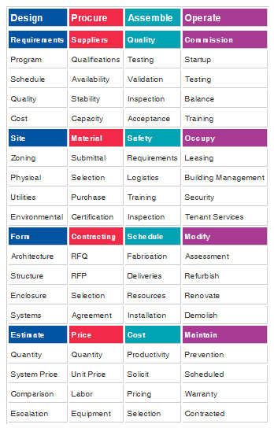
Appendixes

A. BSa Tetrology
Choose from the top or second level classification on the IDM template.
http://www.buildingsmartalliance.org/index.php/projects/projectstructure/

B. Omniclass www.omniclass.org/
Structured Data for an IDM Business Use Case
WHO | Provide the interested parties, stakeholders, and organizations | OmniClass Table 34
WHO/WHOM (Actors) | Provide list of the specific members of the exchange/s | OmniClass Table 33
WHEN  (Phases) | Provide the timeframe or stage for this exchange in the project or building lifecycle (Further refined and used in the process models) | OmniClass Table 31
HOW  (Service) | Provide the process/activity description. Identify in plain English terms the purpose of the exchange. i.e. Cost estimation, energy analysis, etc. (Specific data will be defined in the Exchange Requirements development) | OmniClass Table 32
WHY  (project) | The functional entity (purpose of building or structure) | OmniClass Table 11
WHAT | What may be defined in general terms or made specific with the tables below | OmniClass Table 41,49,21,22,23,35,36
Structured Data Used in Process Model and Exchange Requirements
WHAT | Depending on the phase and the Level of Detail (LoD) “WHAT” can be defined using several OmniClass tables
WHAT | In a BIM exchange the only “product” may be information. | OmniClass Table 36
WHAT | Attributes and properties about a system, element or object | OmniClass Table 41,49
WHAT | Tools and resources needed for the exchange | OmniClass Table 35
WHAT | Products and elements used in the exchange | OmniClass Table 21, 23
WHERE | May be at a structure or space Level of Detail (LoD) | OmniClass Table 36

