bSa, NBIMS Document #:
Date:
Working Group: BIM-GIS
IDM Use Case: BIM-GIS Information Exchange (BIGie)
Version: 1.0

Contents

Section 1. Workgroup IDM Information 3
Section 2. Use Case Narrative 4
Introduction and Problem Statement 4
Narrative 4
Stakeholders: 4
Actors 4
Tools: 4
Section 3. Tasks/Processes 5
Process IFC to GIS 5
Integrate Facility Data with Spatial Information 6
Quality Check 6
Process Map 6
Post-Conditions/Outcome 6
References 6
Appendix: 7

This document has been created by the IDM and MVD Technical Groups in support of NBIMS development and implementation. It is freely distributed to BSa members, industry working groups, and organizations submitting candidate BIM processes for NBIMS consideration.

Authors:
Dianne Davis, CSI, NA IDM Technical Chair
Jan Karlshoj, International IDM Coordinator
Reviewer: Richard See, Technical Chair

This document is based upon the original concept documents authored by Jeff Wix for BuildingSMART.
Additional information provided by: Richard See, Chuck Eastman, GA Tech, Roger Grant, CSI, Louis Hecht.

Section 1. Workgroup IDM Information

IDM Use Case Name: BIM-GIS Spatial Data Information Exchange -BIGie

VERSION HISTORY
No. | Date | Modifications | Author/s

Working Group Members
(participant roles)- Sponsor, Industry Knowledge Expert, WG Leader, Technical Advisor

Name | Organization | Role | Email address
 |  | Working Group Leader

Section 2. Use Case Narrative
IDM Name: BIM-GIS Spatial Data Information Exchange -BIGie
Tetrology Area/s: Operate
Focus Area/s: 36-11 33 00 – Model Documents (model exchanges)

Introduction and Problem Statement
Owners of facilities would like to capture building information in a GIS environment, because of the strong analysis and visualization capabilities, as well as the ability to accurately represent building assets in the real world. It may be preferable to directly exchange this data from a BIM into a GIS environment, at a point in the facilities life cycle when a BIM is the authoritative source on the as-built conditions of that facility.

The standardized exchange of information from BIM to GIS enables the transfer of specific information and solid geometry from the rich database of a BIM model to GIS environment that is best suited to analysis. This use case is of the Basic Use Case type, in which the data exchange flows typically in one direction; from a BIM of a completed facility to a generic data structure to be imported into GIS applications.

Narrative
Phase for Use Case – 31-40-50-00 Commissioning Phase, 31-50-10-00 Occupancy Phase, 31-50-20-00 Facility Management Phase, 31-50-30-00 Facility Re-Use Phase, 31-50 70 00 Facility Repair Phase

Context and Scope
The scope of this information exchange is similar to a Facility Management Handover use case, with the major exception that geometry data is also required. Generally, the datasets involved are:
- Architectural As-Built BIM
- MEP BIM
- Inventories from surveying or previous FM handover

Related Use Cases and Inter-dependent Processes
Handover to FM (GSC-001)

Stakeholders:
Owner, Local Authorities, Occupant, Public
Actors:
33-21 00 00 Design 33-31 31 00 GIS Engineering 33-55 24 00 Facility Operations

Tools:
BIM Model, Data Processing tools (native to GIS or external

Non-Functional Requirements

Section 3. Tasks/Processes

Process IFC to GIS
Moving from IFC is a fundamentally different from GIS in some ways and the data exchange requires a data processing step; this eliminates unnecessary data from the BIM model and enters data into GIS in a way that facilitates analysis.
The information requirements can vary, but spatial information exchanged will likely include the following:
- Site-Level
  - Site Boundary
  - Latitude & Longitude at reference point
  - Reference Elevation (above sea level)
  - Land Title Number
  - Site Address
- Building-level
  - Building address & footprint
  - Building owner
  - Number & hierarchy of stories
  - Vertical connections between stories (Elevators, stairs, ramps)
- Story-level
  - Story base elevation
  - Spaces contained within story
  - Floor plan line work
- Space-level
  - Boundary representation of spaces
  - Space name, ID, department, etc…
  - Flooring elevation & material
  - Ceiling height & material
  - Fenestration Area & Location
  - ADA Accessible
  - Occupancy Type
  - Capacity
  - Interconnections between spaces
- Equipment
  - Many elements

The BIM-GIS workflow is the instruction set for exchanging information from BIM to GIS. The workflow specifically defines the information input requirements for the process. Due to the wide range of BIM modeling software and the variance in IFC output, workflow development will be specific to software platform, among other factors.
Example: Elevators are typically modeled in BIM software as equipment and do not inherently create logical connections between Building Storeys (although IfcVerticalTransport does provide this type of relationship). The BIM-GIS workflow should be developed to address this issue, to output a GIS model that shows a connection between floors via elevator.

Integrate Facility Data with Spatial Information
Depending on the data richness of the BIM, it may be desirable to supplement the BIM with facility management data. This may be an ongoing activity, where facility management data is updated to the GIS system throughout the lifecycle of the facility.

Quality Check
Provide an output to Design and Operations which facilitates a quality check of the data processing operations. The output should be in a form that can be utilized to quickly verify the accuracy of the respective datasets.

Process Map

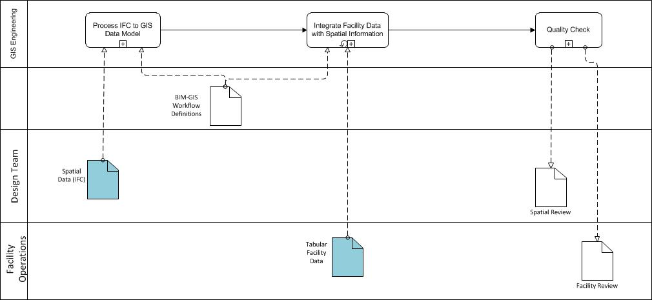

Post-Conditions/Outcome
The result of this process will be a GIS model that contains spatial data of a constructed facility, to include 3D representations of interior spaces.

References
Leibich, T. (2007). Ifc2x edition 3 technical corrigendum 1. Retrieved from http://buildingsmart-tech.org/ifc/IFC2x3/TC1/html/index.htm
Karlshøj, J. (2011). Overview of information delivery manuals independent of their status. Retrieved from http://iug.buildingsmart.com/idms/overview

Appendix:
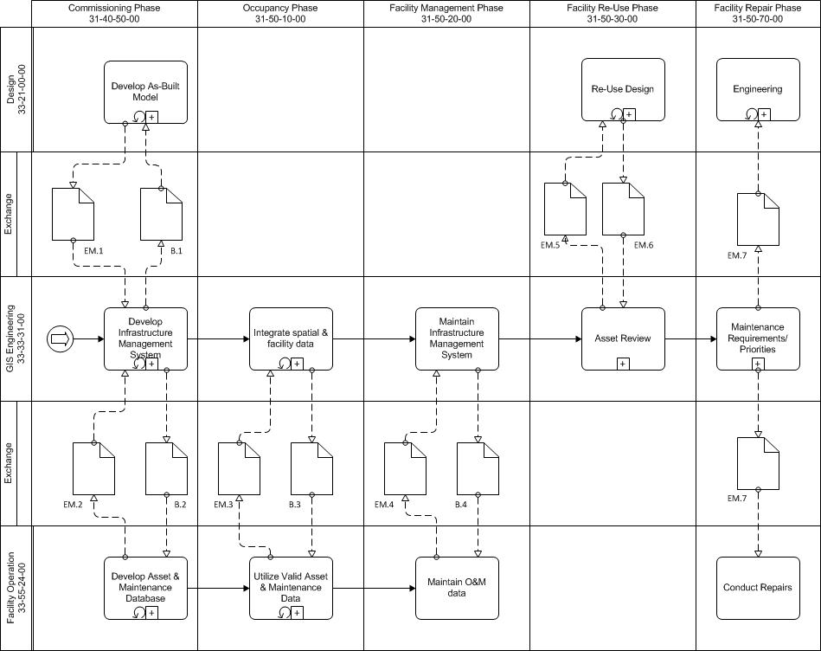
Figure 1: Alternate Process Map

