12/17/12

**Autodesk Revit Software Configuration Guide for January 2013 COBie Challenge**

This document helps you get started using the Add-in application for COBie developed for use with Autodesk Revit 2013 software.

Autodesk’s building information modeling (BIM) solutions help make facility lifecycle management practices easier, more efficient, and less costly. An Add-in application (small software program) has been developed using the Revit API software development toolkit, for use in Revit Architecture to accommodate project data management for the current COBie standard.

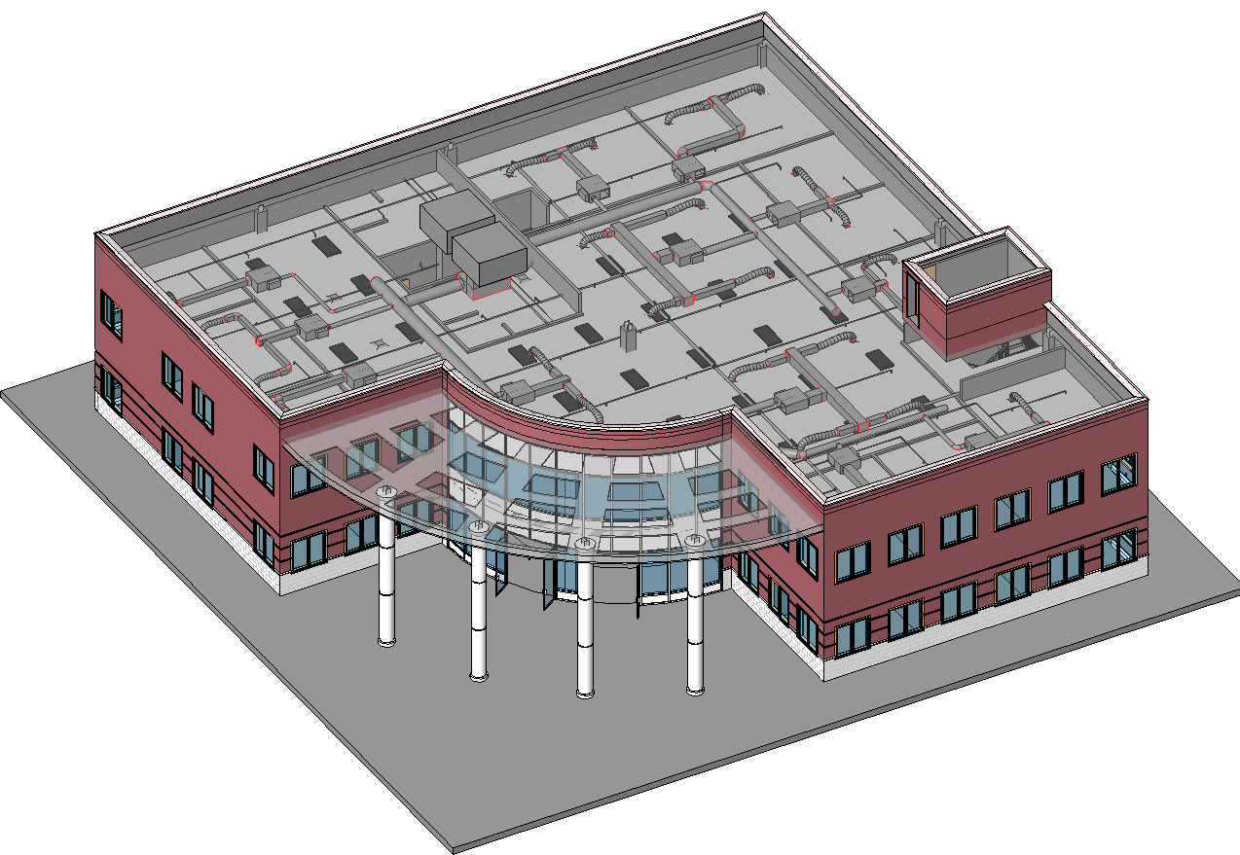

**Streamlined Autodesk Revit Software Configuration Steps for January 2013 COBie Challenge**

The table below outlines the software configuration steps needed to replicate the Revit Software configuration used by Autodesk in the preparation of our submission for the January 2013 COBie Challenge.

|  |  |
| --- | --- |
| **Configuration Step** | **Notes** |
| **Install Autodesk Revit 2013** | * If you do not have access Revit 2013 you can download a 30 day trial at [**http://usa.autodesk.com/revit/trial/**](http://usa.autodesk.com/revit/trial/) * This can just be the default installation options for Revit * System requirements are detailed at <http://usa.autodesk.com/revit/system-requirements/> * If you already have Revit 2013 installed on your system, make sure that you have applied all available maintenance updates and/or hot fixes from <http://usa.autodesk.com/support/> |
| **Install COBie Add-in Demonstration Application for Autodesk Revit 2013** | * Autodesk Revit 2013 COBie Toolkit contains template files, macros and other items to be applied to Revit for preparing COBie formatted models. * All of the files needed for the Revit COBie Add-in installation and setup are contained in the downloadable distribution file that is included with this submission. **SetupCOBieV2_30forRevit2013x64.zip** (for 64-bit computers) or **SetupCOBieV2_30forRevit2013x86.zip** (for 32-bit computers). Please download the file appropriate for your workstation. * Open the zip file and double click on setup to install and configure this COBie add-in and required templates on the target computer * More extensive details about installing and using this toolkit can be found in the document “Using the COBie Add-in Demonstration Application for Autodesk Revit 2013” which is included with the Autodesk Submission |
| **Install the Revit 2013 Open Source IFC Export *(optional)*** | * If you plan on using any IFC files exported from Revit as part of your COBie workflow, note that the most up to date version of the IFC exporter is in the Autodesk IFC Export Open Source distribution <http://sourceforge.net/p/ifcexporter/home/Home/> * There are special Revit Share Parameters files for housing some IFC specific parameters that do not by default get attached to Revit Elements. Details of these files and where to download them are in the Wikihelp for Revit. <http://wikihelp.autodesk.com/Revit/enu/2013/Help/00001-Revit_He0/1468-Document1468/2171-Print_Ex2171/2172-Export2172/2216-Exportin2216/2221-IFC-Spec2221> |

The Autodesk Revit 2013 COBie Toolkit is an add-in for Revit Architecture, Revit MEP and Revit Structure. The toolkit was developed to support COBie Version2 Release 4. The toolkit supports COBie export for the US and UK regions.

The COBie Toolkit installs the includes the following components

1. The Autodesk Revit COBie application
2. COBie Shared parameter file

*COBie SharedParams V1.0.txt*   
These hared parameters are parameters are to add properties in the model for specific COBie data that is not already predefined in the family file or the project template.

1. COBie export Microsoft Excel 2010 blank COBie Version 2 Release 4 Templates

The templates are preformatted Microsoft Excel 2010 spreadsheets used for the COBie export. There is a separate template for the US and UK.

* 1. COBieTemplate2_4_US.xlsx
  2. COBie-UK-2012-template.xlsx

1. Autodesk Revit 2013 COBie Toolkit documentation

This document

After installing the tool, a tab named COBie will be added to the Revit Menu. The COBie Panel provides the tools needed to generate a COBie file from Autodesk Revit.

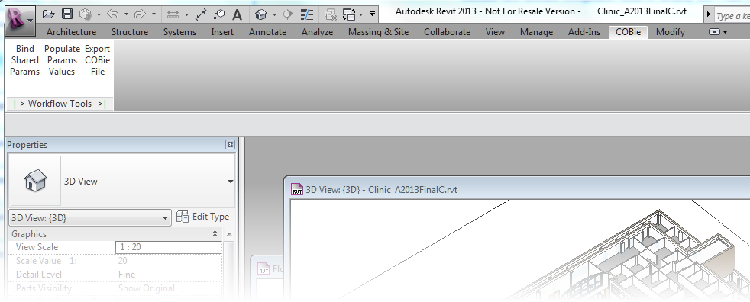

There are three main steps to prepare and export COBie data from Revit.

* **Create/Bind specific Shared Parameters used for COBie export**

This function creates and binds all required shared parameters to store the required data for COBie

* **Populate these parameters**

This function provides the ability to automatically populate COBie fields and reformat and transfer internal Revit parameters. The user can specify COBie data fields to be automatically populated with values specified by selecting the various options.

* **Export COBie File**  
  Export to COBie data directly to Microsoft Excel (xls/xlsx) or optionally to XML XLS(X) file (or optionally to XML). Options include the ability to append data to existing COBie spreadsheets.

**Setting up the Revit Project for COBie**

**Create/Bind specific Shared Parameters**

This function creates specific Shared Parameters used for COBie export, then binds those parameters to all applicable Revit Model categories. This task needs to be executed only once for each Revit Model and can be used when creating a new Revit Project /Model or run from within an existing Revit Model.

Select the ***Bind Shared Parameters*** button on the COBie Panel

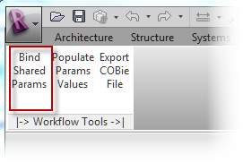

Select the ***Bind all COBie Params*** button

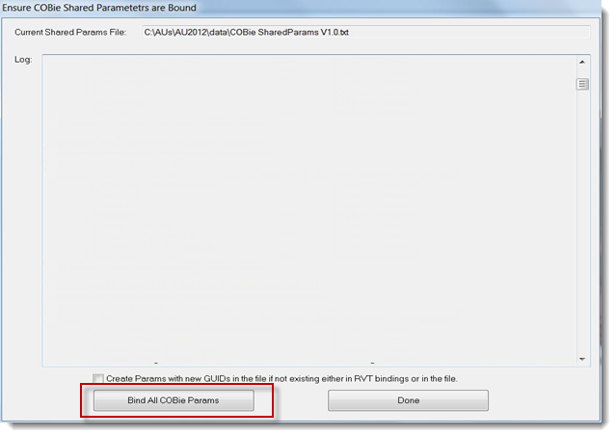

After processing, a log will be displayed. The log shows what shared parameters were created and the Revit categories the parameters are bound to.

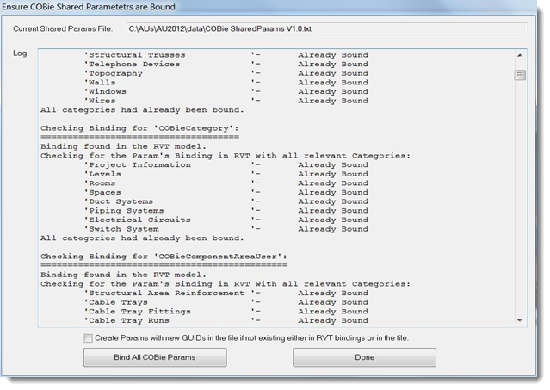.

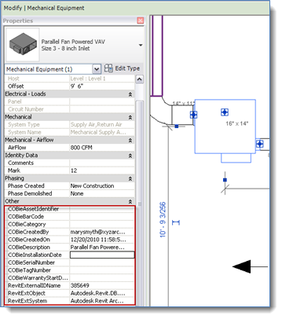**Creating COBie content**

As a project model is developed and components are added, users can enter COBie data in the models into the appropriate COBie data fields. The data can be entered using any of the standard Revit tools, including schedule views, or on an object’s Revit Properties palette. For additional information on adding data to the Revit model, please refer to the appropriate Autodesk Revit Documentation resources.

**Populate Shared Parameters**

This function populates COBie “project level” parameter fields through an automated routine.

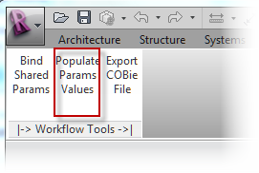

Select the ***Populate Params Values*** button on the COBie Panel

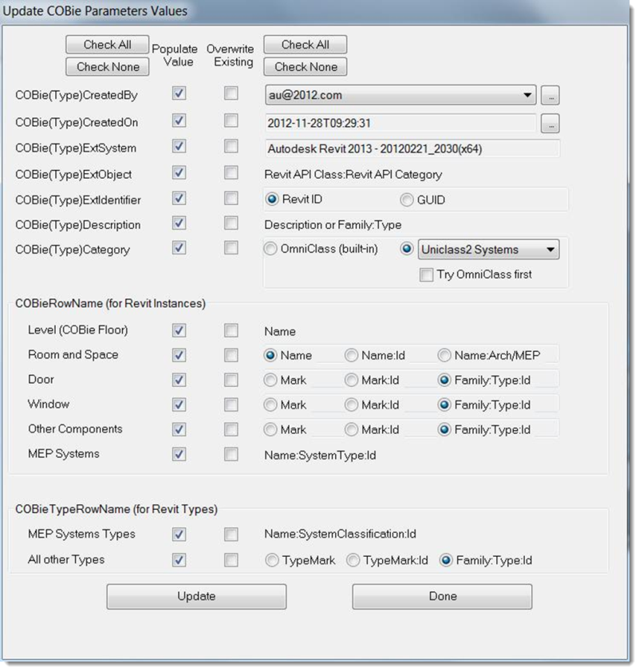

**The following parameters can be processed by this dialog**

* + - COBie (Type)Created By User name (email address is the COBie required format)
    - COBie(Type)CreatedOn Date created
    - COBie(Type)ExtSystem Software used (e.g. Autodesk Revit Architecture 2013)
    - COBie(Type)ExtObject Revit internal object name
    - COBie(Type)ExtIdentifier Select Revit UniqueID or GUID to be used as unique

identifier to model objects.

* + - COBie(Type)Description Type Description/Family Name and Type
    - COBie(Type)Category) Populate OmniClass Parameter from Revit Family

**COBieRowName (for Revit Instances)**

* + - Configure what Revit parameter to use for the *COBie Name* field for each respective instance object type
      * Rooms and Spaces
      * Doors
      * Windows
      * Other Components
      * MEP Systems

**COBieTypeRowName (for Revit Types)**

* + - Configure what Revit parameter to use for the *COBie Name* field for each respective instance object type
      * MEP Systems Type
      * All other Types

This dialog also provides the ability to add names or COBie Contacts to the model by electing the button to the right of the name selector.

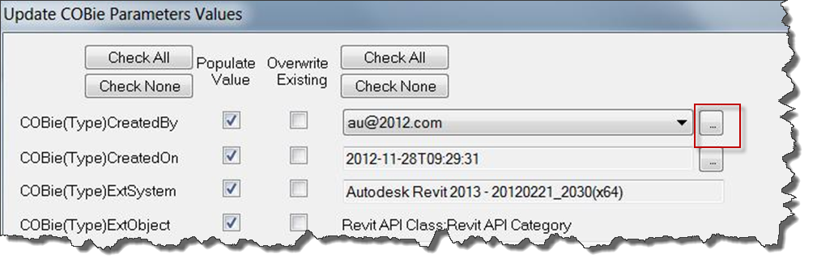

This will open a winodow that allows names to be entered directly into the model and will be exported into the COBie spreadsheet.

* + - 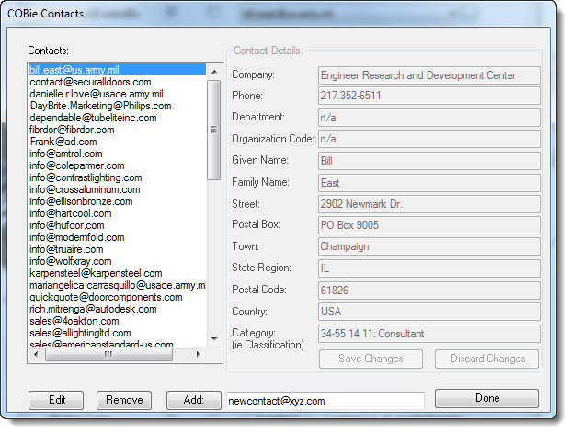

**Export COBie data to spread sheet or xml file**

This function sets up and exports the COBie data to a COBie spread sheet or XML file. The functions provide the ability to select what data is to be extracted and exported.

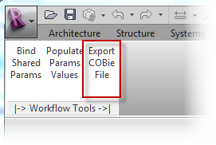

Select the ***Export COBie File*** button on the COBie Panel

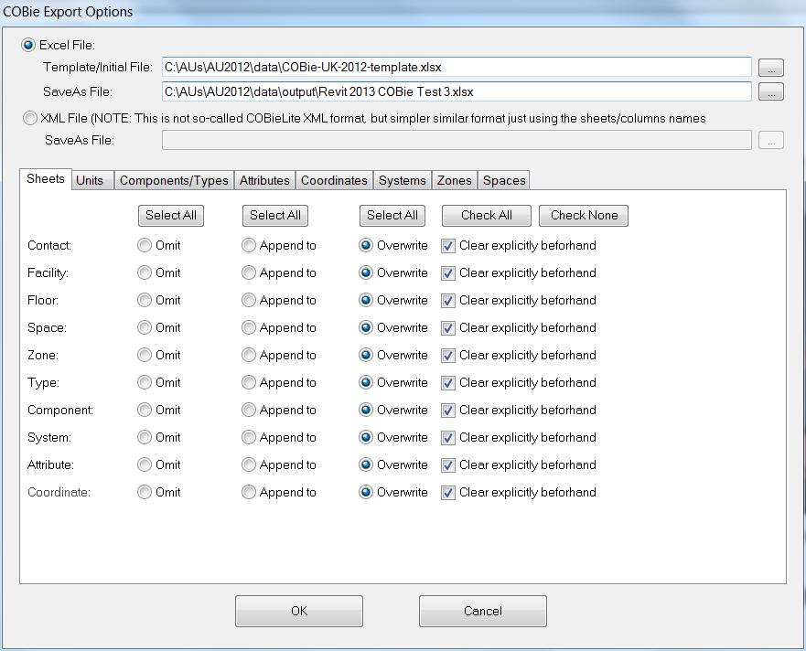

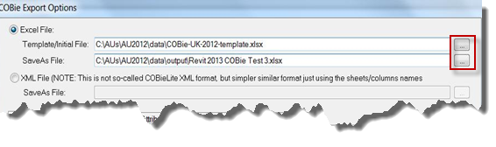

**Sheet Selection and Options**

Select the buttons to the right of the file names to select the COBie Template to use for input and the exported file to create or append to.

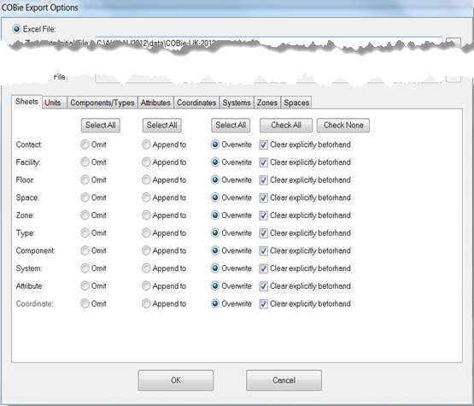

Select what sheet or sheets to export and whether to append to an existing sheet or sheets or overwrite the existing data.

**Unit Selection**

Select the buttons to the right of the file names to select the COBie Template to use for input and the exported file to create or append to.

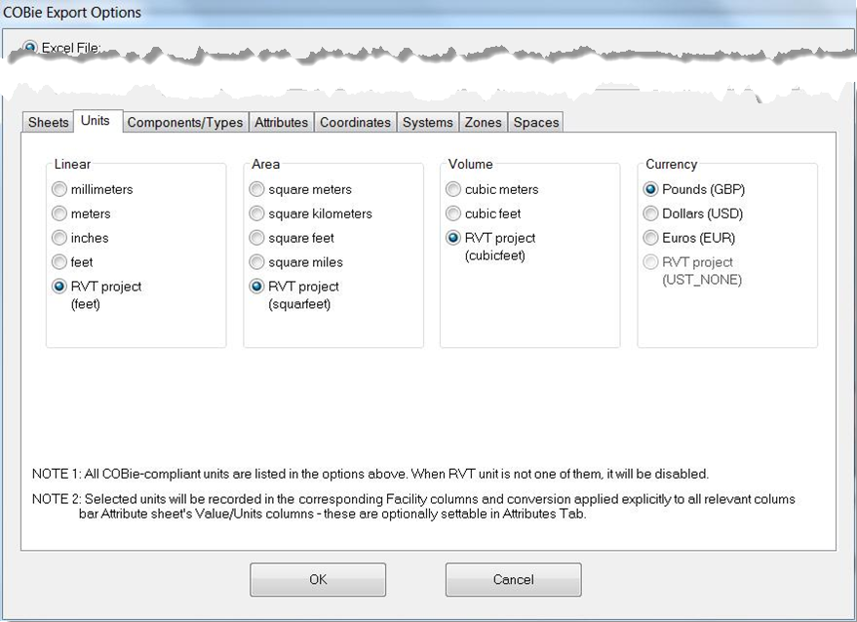

Select the Linear, Area, Volume and Currency units for export. These settings allow the user to override the existing units in the model.

**Component and Type Selection**

This tab controls what Revit Families and Types are select from the model for export. Selection now affords significant flexibility for selection

Options include:

* + - Selected Elements on the screen
    - All Families in the Active Revit View
    - Families with the COBieTypeSchedule Parameter set to true (compatibility to previous Revit Toolkit)
    - Selected Types and their components (details below)
    - All Model Type and Components

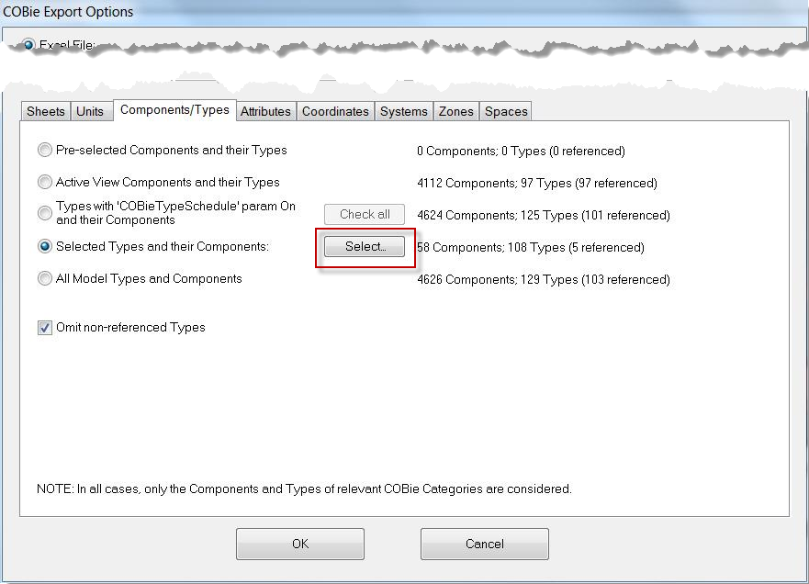

Selecting Families to Export

By picking the *Select…*button on the Components/Type Tab, the following dialog is presented.

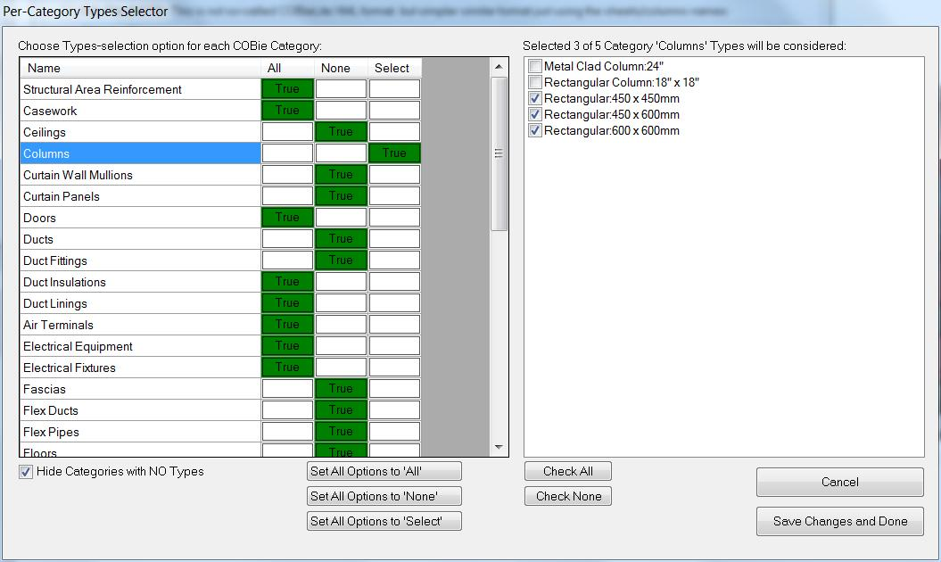

Using this this dialog, a user can select All Families and Types, no Families and Types for any Revit Category. In addition, users can selectively choose the Families and Types within any or all categories. Clicking in the Select Box for a category will allow selection of what Families and Types to export.

**Attribute Selection**

This tab controls what additional attributes are to be are selected from the model for export. Individual attributes can be selected by Revit Category.

Additionally Independent unit conversion can be applied to the attributes. This facilitates differences in units for certain types of components, such as imperial pie sizes in some countries which use metric.

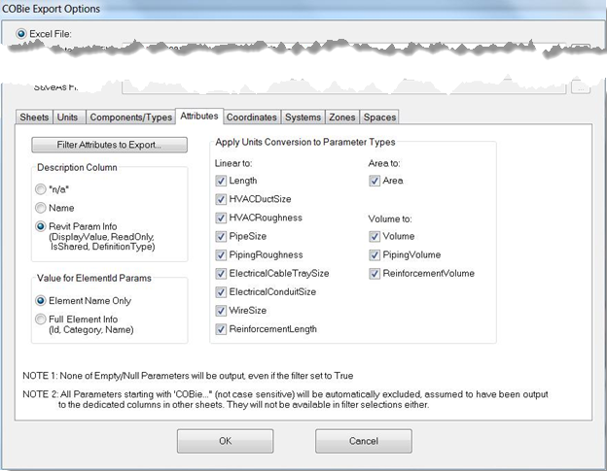

Selecting Attributes to Export

By picking the *Select…*button on the Components/Type Tab, the following dialog is presented.

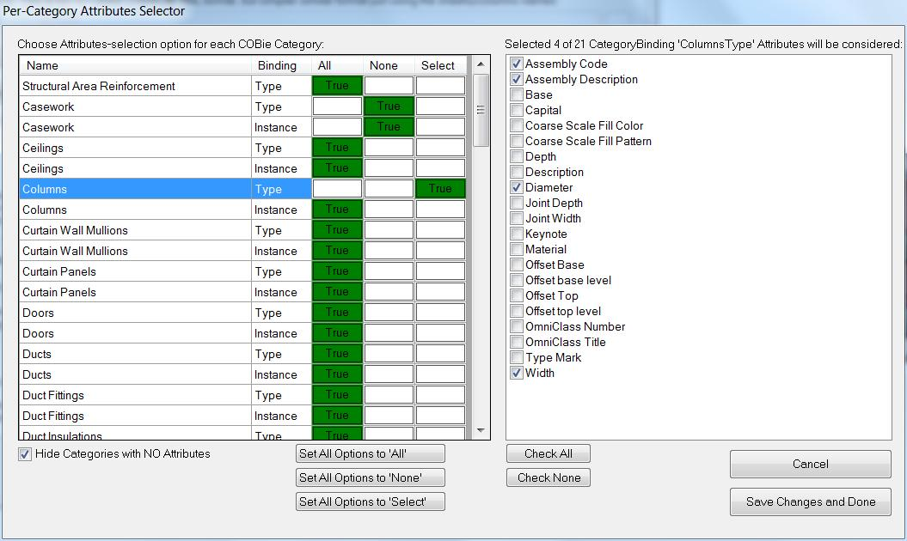

Using this this dialog, a user can select any attributes for any Revit Category. In addition, users can selectively choose the attributes within any or all categories. Clicking in the Select Box for a category will allow selection of what Attributes to export.

**Coordinate Export**

This tab controls what whether to export coordinates to the COBie file. Location/insertion points and/or bounding boxes can be exported. Options allow for selection of what type objects to include in the export.

* Components
* Rooms/Spaces
* Floors

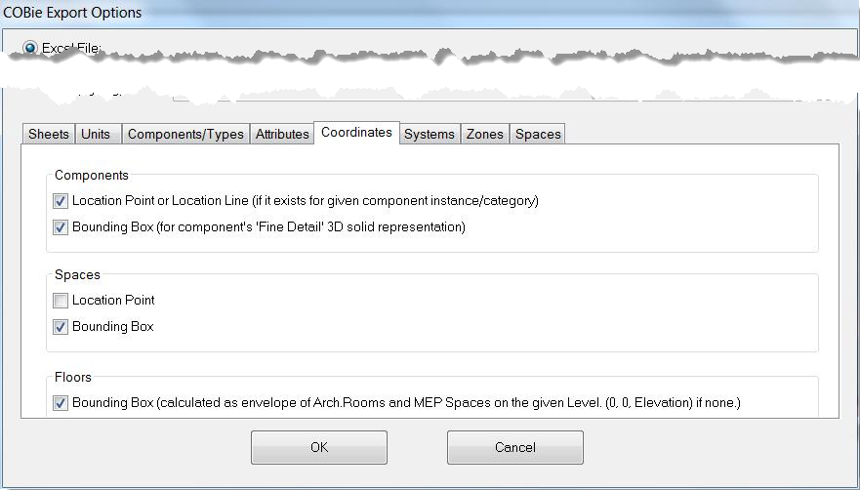

**Systems Export**

This tab controls the export of Revit Systems.

The Revit Systems that can be exported are

|  |  |
| --- | --- |
| * + - Duct Systems     - Piping Systems | * + - Switch Systems     - Electrical Circuits |

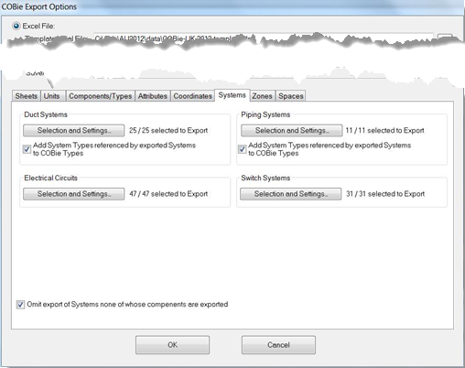

Selections and settings allow users to select which components are to be exported

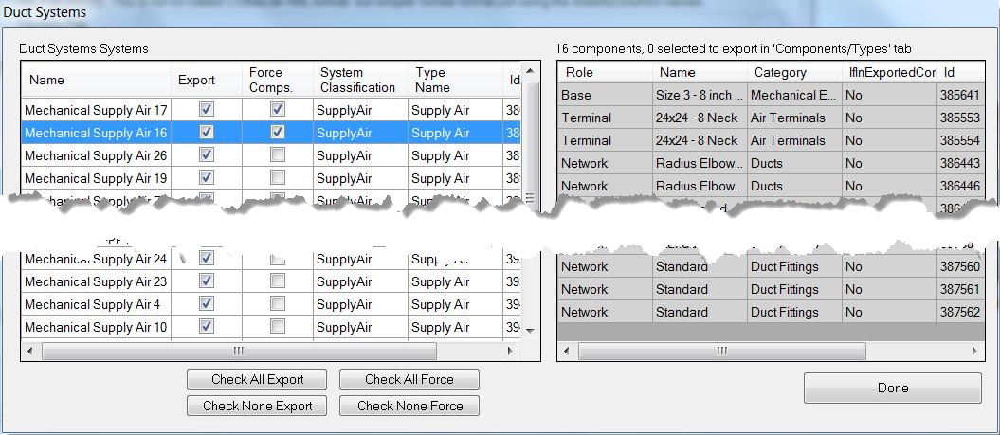

**Zones Export**

This tab controls the export of Zones Created in Revit. A zone can be created by adding a zone parameter to the Revit project and assigning the rooms to the that zone. This tools allows for multiple zones to be defined and exported.

Users select the zones to export by selecting the Zones Tab.

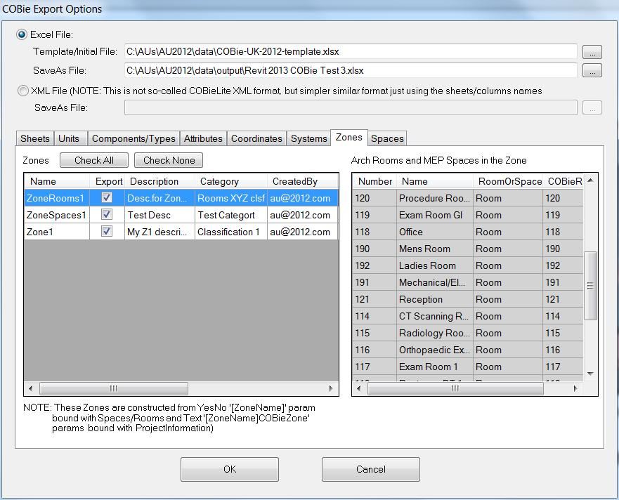

**Spaces Export**

This tab controls the export of Revit Rooms and Spaces to COBie. Revit provides architectural rooms and MEP spaces. This tab allows for the selection of whether to associate components for spatial containment from the Room and or Space object. This allows for greater flexibility in determining where a particular piece of equipment is located.

Users select the space containment options by selecting the SpacesTab.

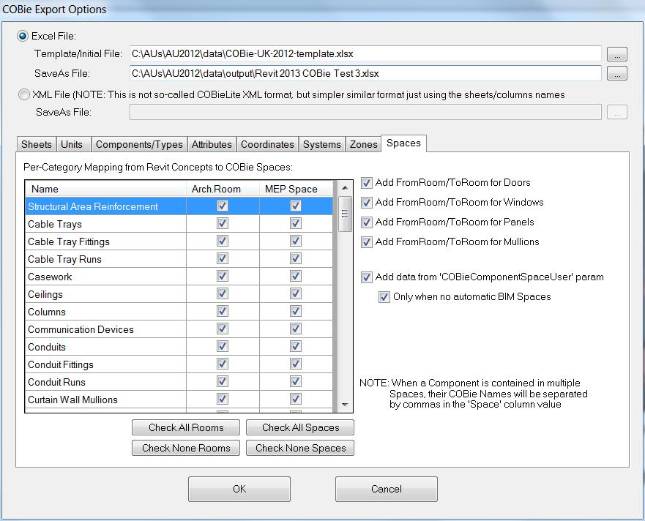

**Exporting COBie data**

After making all the selections for the COBie data export, clicking the OK Button at the bottom of the form will initiate the export.

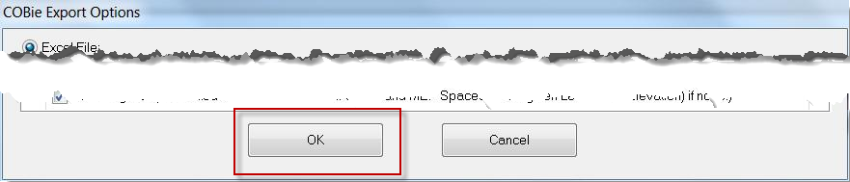

After the processing is complete, the final COBie Spreadsheet will be displayed.

**COBie Field Configurations**

The following tables provide the configuration and field mapping between The Autodesk Revit internal and shared parameters and the COBie Version2 Release 4 schema. The tables have 2 or three columns depending on how the particular worksheet or table is configured. The following legend defines the color scheme used in this section

|  |  |
| --- | --- |
| **Color Legend** | Revit Built-in Parameter |
| Revit Shared Parameter (COBie) |
| Calculated/Conditional output |

The first column represents the COBie field/column name, the second column defines the Autodesk Revit Shared Parameter which stores the data or the Revit built in property from where the value is exported. The optional third column defines an optional parameter to allow for overriding built-in Revit parameter with a user parameter. The Revit value is only overridden if a value exists in the parameter defined in the third column.



